02:38
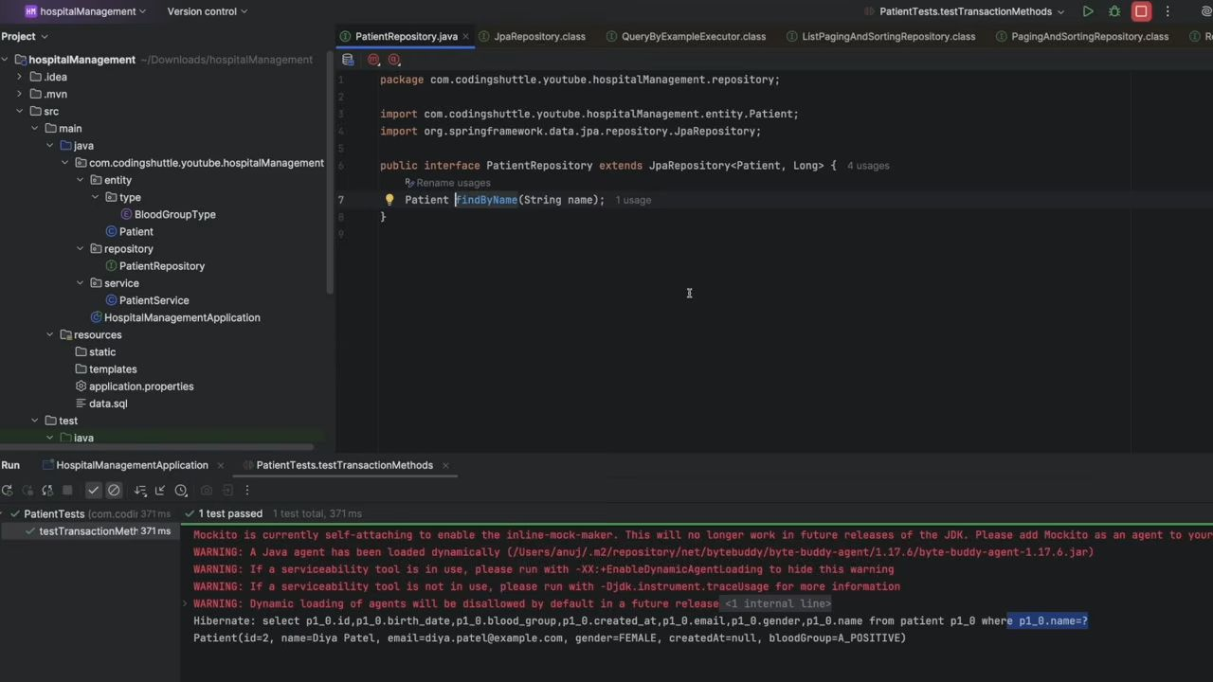
This findByName method doesn't exist but still this works but how ?
This is called as JPA Query Methods and we have rules to wrtie it.
In Spring Data JPA, query methods let you define SQL-like queries just by writing method names inside your repository interface. Spring parses the method name and generates the query automatically.

1. Basic Structure
public interface PatientRepository extends JpaRepository<Patient, Long> {
// Syntax: findBy<FieldName>
Optional<Patient> findByEmail(String email);
// Multiple conditions: findBy<Field1>And<Field2> List<Patient> findByNameAndBirthDate(String name, LocalDate birthDate); // Variations with keywords List<Patient> findByAgeGreaterThan(int age);
}

2. Common Keywords
Keyword Meaning (SQL Equivalent) findBy SELECT FROM ... WHERE countBy SELECT COUNT() FROM ... WHERE existsBy SELECT CASE WHEN COUNT(*) > 0 THEN true ELSE false END deleteBy DELETE FROM ... WHERE removeBy Same as deleteBy

3. Conditional Expressions
Keyword Example Equivalent SQL And findByNameAndAge WHERE name=? AND age=? Or findByNameOrEmail WHERE name=? OR email=? Between findByAgeBetween(20,30) BETWEEN 20 AND 30 LessThan findByAgeLessThan(30) < 30 GreaterThan findByAgeGreaterThan(30) > 30 Like findByNameLike("%John%") LIKE '%John%' NotLike findByNameNotLike("%John%") NOT LIKE StartingWith findByNameStartingWith("Jo") LIKE 'Jo%' EndingWith findByNameEndingWith("hn") LIKE '%hn' Containing findByNameContaining("oh") LIKE '%oh%' In findByAgeIn(List<Integer> ages) IN (..) NotIn findByAgeNotIn(List<Integer> ages) NOT IN (..) IsNull findByEmailIsNull() IS NULL IsNotNull findByEmailIsNotNull() IS NOT NULL True / False findByActiveTrue() WHERE active=true

4. Sorting and Limiting
// Sort by Age Ascending
List<Patient> findByOrderByAgeAsc();
// Sort by Name Descending
List<Patient> findByOrderByNameDesc();
// Top/First N
Patient findTopByOrderByAgeDesc();
List<Patient> findFirst3ByOrderByAgeAsc();

5. Custom Queries using @Query
If method names get too long or complex, use JPQL or native SQL.
public interface PatientRepository extends JpaRepository<Patient, Long> {
// JPQL @Query("SELECT p FROM Patient p WHERE p.name = :name") List<Patient> findByPatientName(@Param("name") String name); // Native Query @Query(value = "SELECT * FROM patient WHERE email = :email", nativeQuery = true) Patient findByEmailNative(@Param("email") String email);
}
✅ Summary:
- Use method naming rules for simple queries.
- Use @Query with JPQL or native SQL for complex queries.
- Always return Optional<T> for single results to avoid null.
- Use List<T> or Page<T> when multiple results are possible.
Here’s a JPA Query Methods Cheat Sheet you can keep as a quick reference:

📌 JPA Query Methods Cheat Sheet

🔹 Basic
Optional<User> findById(Long id);
List<User> findAll();
Optional<User> findByEmail(String email);

🔹 Comparisons
Method Keyword Example SQL Equivalent Is, Equals findByName(String name) WHERE name = ? IsNot, Not findByNameNot(String name) WHERE name <> ? LessThan findByAgeLessThan(int age) WHERE age < ? LessThanEqual findByAgeLessThanEqual(int age) WHERE age <= ? GreaterThan findByAgeGreaterThan(int age) WHERE age > ? GreaterThanEqual findByAgeGreaterThanEqual(int age) WHERE age >= ? Between findByAgeBetween(int start, int end) BETWEEN ? AND ?

🔹 Null Checks
List<User> findByEmailIsNull();
List<User> findByEmailIsNotNull();

🔹 Booleans
List<User> findByActiveTrue();
List<User> findByActiveFalse();

🔹 String Matching
Method Keyword Example SQL Equivalent Like findByNameLike("%John%") LIKE '%John%' NotLike findByNameNotLike("%John%") NOT LIKE StartingWith findByNameStartingWith("Jo") LIKE 'Jo%' EndingWith findByNameEndingWith("hn") LIKE '%hn' Containing findByNameContaining("oh") LIKE '%oh%'

🔹 Collections
List<User> findByAgeIn(List<Integer> ages);
List<User> findByAgeNotIn(List<Integer> ages);

🔹 Logical Operators
List<User> findByNameAndEmail(String name, String email);
List<User> findByNameOrEmail(String name, String email);

🔹 Ordering & Limiting
List<User> findByOrderByAgeAsc();
List<User> findByOrderByAgeDesc();
User findTopByOrderByAgeDesc();
List<User> findFirst3ByOrderByAgeAsc();

🔹 Count & Exists
long countByActiveTrue();
boolean existsByEmail(String email);

🔹 Delete
void deleteByEmail(String email);
long deleteByActiveFalse();

🔹 Custom Queries with @Query
// JPQL
@Query("SELECT u FROM User u WHERE u.name = :name")
List<User> findByUserName(@Param("name") String name);
// Native SQL
@Query(value = "SELECT * FROM users WHERE email = :email", nativeQuery = true)
User findByEmailNative(@Param("email") String email);
✅ With this cheat sheet, you can cover 90% of use cases in Spring Data JPA without writing manual queries.
Great 🚀 Let’s build a real-world example repository showing all these query methods together.

📌 Example: UserRepository
package com.example.demo.repository;
import com.example.demo.entity.User;
import org.springframework.data.jpa.repository.JpaRepository;
import org.springframework.data.jpa.repository.Query;
import org.springframework.data.repository.query.Param;
import java.time.LocalDate;
import java.util.List;
import java.util.Optional;
public interface UserRepository extends JpaRepository<User, Long> {
// 🔹 Basic Optional<User> findByEmail(String email); List<User> findByName(String name); // 🔹 Comparisons List<User> findByAgeGreaterThan(int age); List<User> findByAgeBetween(int start, int end); // 🔹 Null Checks List<User> findByEmailIsNull(); List<User> findByEmailIsNotNull(); // 🔹 Boolean List<User> findByActiveTrue(); List<User> findByActiveFalse(); // 🔹 String Matching List<User> findByNameContaining(String keyword); List<User> findByNameStartingWith(String prefix); List<User> findByNameEndingWith(String suffix); // 🔹 Collections List<User> findByAgeIn(List<Integer> ages); // 🔹 Logical Operators List<User> findByNameAndEmail(String name, String email); List<User> findByNameOrEmail(String name, String email); // 🔹 Ordering & Limiting List<User> findByOrderByAgeAsc(); List<User> findByOrderByAgeDesc(); User findTopByOrderByAgeDesc(); List<User> findFirst3ByOrderByAgeAsc(); // 🔹 Count & Exists long countByActiveTrue(); boolean existsByEmail(String email); // 🔹 Delete long deleteByActiveFalse(); void deleteByEmail(String email); // 🔹 Custom JPQL Query @Query("SELECT u FROM User u WHERE u.name = :name AND u.birthDate = :birthDate") List<User> findByNameAndBirthDate(@Param("name") String name, @Param("birthDate") LocalDate birthDate); // 🔹 Custom Native SQL Query @Query(value = "SELECT * FROM users WHERE email = :email", nativeQuery = true) User findByEmailNative(@Param("email") String email);
}

📌 Example Entity: User
package com.example.demo.entity;
import jakarta.persistence.;import lombok.;
import java.time.LocalDate;
@Entity
@Getter
@Setter
@NoArgsConstructor
@AllArgsConstructor
@Builder
@Table(name = "users")
public class User {
@Id @GeneratedValue(strategy = GenerationType.IDENTITY) private Long id; private String name; @Column(unique = true) private String email; private int age; private boolean active; private LocalDate birthDate;
}
✅ With this setup, you can test almost all query methods in a real project.
You Can also refer to this doc: https://docs.spring.io/spring-data/jpa/reference/jpa/query-methods.html
Till Now we have seen query Methods now we will see @Query annotation through which we can write our own JPQL.
27:31
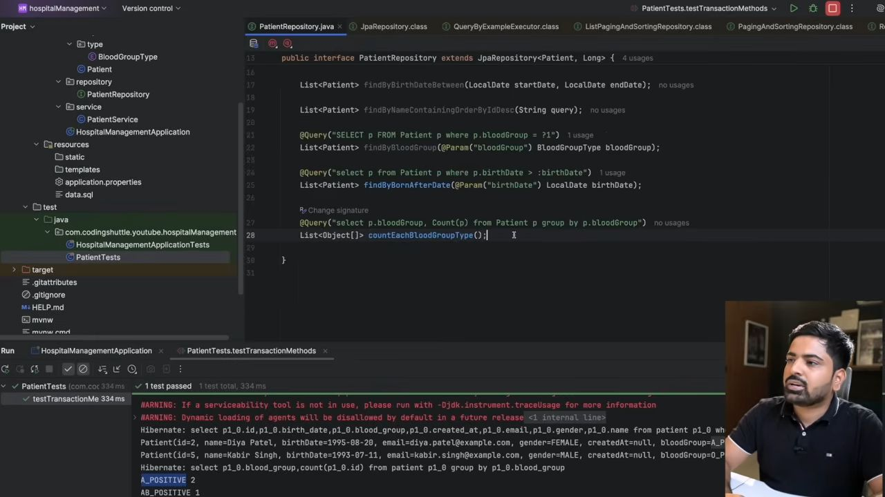
public class Patient {
@Id
@GeneratedValue(strategy = GenerationType.IDENTITY)
private Long id;
@Column(name = "name", nullable = false, length = 40) private String name; private LocalDate birthDate; @Column(unique = true) private String email; @ToString.Exclude private String gender; @CreationTimestamp @Column(updatable = false) private LocalDateTime createAt; @Enumerated(EnumType.STRING) private BlooadGroupType bloodGroup;
}
This query which we have written is JPQL not a sql that's why we used Patient (same as entity name) not patient and similarily bloodGroup not blood_group
@Param is parameter.
We can also write Native Query Which is in SQL or whatever database you are using here we are using PLSQL which is same as SQL.
@Query(value = "SELECT * FROM patient", nativeQuery = true)
List<Patient> findAllPatients();
Here you can see i have used patient which is table name not Patient which is entity name as we are wrting SQL directly not JPQL. And we need to tell hibernate also that you don't need to convert it into sql as it is already as SQL not JPQL. That's why we have used nativeQuery = true. By default it is false.
You can also write modify query in SQL like this: @Transactional
@Modifying
@Query("UPDATE Patient p SET p.name = :name where p.id = :id")
int updateNameWithId(@Param("name") String name, @Param("id") Long id);

Projection in JPQL
Let’s break down Projection in JPQL in simple English with examples.

🔹 What is Projection in JPQL?
- Projection means selecting only specific fields (columns) instead of fetching the whole entity.
- Normally, when you write SELECT e FROM Entity e, JPA returns the entire entity object.
- But sometimes you only need a few fields (like name and email) → that’s where Projection helps.

🔹 Types of Projection in JPQL
- Entity Projection → Returns full entity object
@Query("SELECT p FROM Patient p")
List<Patient> findAllPatients();
- 👉 This returns full Patient entity.
- Scalar Projection → Returns specific fields as Object[]
@Query("SELECT p.name, p.email FROM Patient p")
List<Object[]> findPatientNamesAndEmails();
- 👉 Each row will be an Object[] →
- row[0] = name
- row[1] = email
- Usage:
List<Object[]> results = repo.findPatientNamesAndEmails();
for(Object[] row : results) {
System.out.println("Name: " + row[0] + ", Email: " + row[1]);
}
- DTO (Constructor) Projection → Directly map fields into a DTO class
public class PatientDTO {
private String name;
private String email;
public PatientDTO(String name, String email) { this.name = name; this.email = email; } // getters
}
- JPQL:
@Query("SELECT new com.example.demo.dto.PatientDTO(p.name, p.email) FROM Patient p")
List<PatientDTO> findPatientNameAndEmailDTO();
- 👉 This directly gives you a list of DTOs instead of Object[].

🔹 When to use which?
- Entity Projection → When you need full entity with all fields.
- Scalar Projection → When you just need a few fields quickly.
- DTO Projection → Best practice when working in real projects → clean, type-safe, and avoids dealing with Object[].
✅ Summary:
- Projection = selecting specific data instead of whole entity.
- JPQL allows Entity, Scalar, and DTO Constructor projections.
- DTO Projection is most used in real-world apps.
Example of Projection
@Query("SELECT new com.RohitSpringBootProject.hospitalManagement.dto.BloodGroupCountResponseEntity(p.bloodGroup," + "Count(p)) FROM Patient p group by p.bloodGroup")
List<BloodGroupCountResponseEntity> countEachBloodGroupTypee();
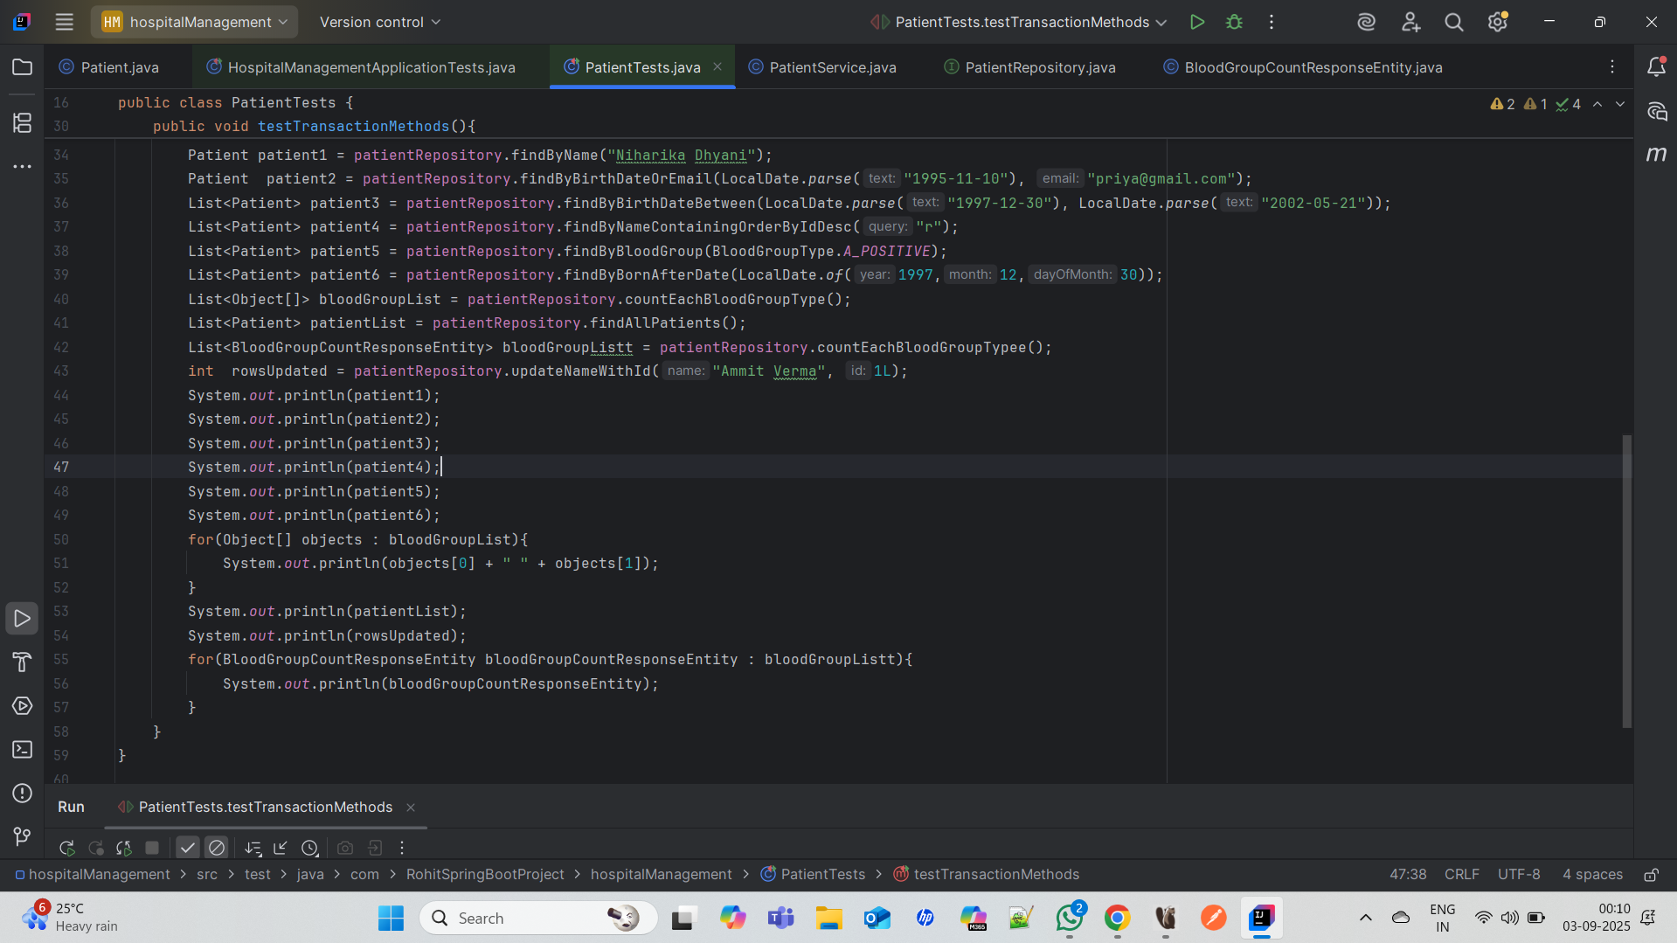
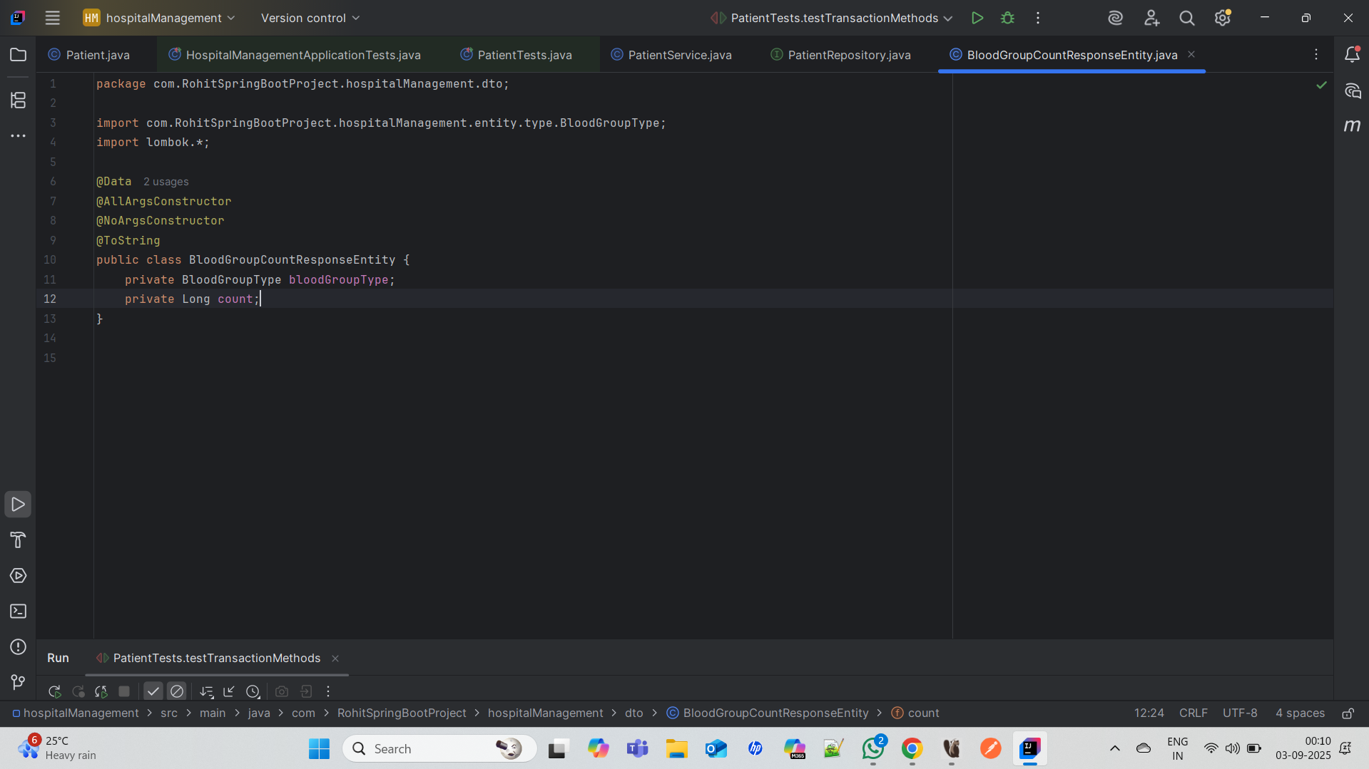
Perfect bhai 👌 Ab main tujhe Pagination + Sorting + Filtering ka step-by-step flow ek story jaisa explain karta hoon, taaki tu clearly samajh paaye.

🔹 Step 1: User (Client) Sends Request
Suppose tu Postman ya Frontend se API call karta hai:
👉 Example Request
http://localhost:8080/users?page=0&size=3&sortBy=name&sortDir=asc
➡ Iska matlab:
- Page 0 (first page)
- Size 3 (sirf 3 records ek baar me)
- Sort by name in ascending order

🔹 Step 2: Controller Receives Request
@GetMapping
public Page<User> getUsers(
@RequestParam(defaultValue = "0") int page,
@RequestParam(defaultValue = "5") int size,
@RequestParam(defaultValue = "id") String sortBy,
@RequestParam(defaultValue = "asc") String sortDir) {
return userService.getUsers(page, size, sortBy, sortDir);
}
👉 Controller query parameters ko read karega (page, size, sortBy, sortDir) aur Service ko bhej dega.

🔹 Step 3: Service Prepares Pageable
public Page<User> getUsers(int page, int size, String sortBy, String sortDir) {
Sort sort = sortDir.equalsIgnoreCase("asc")
? Sort.by(sortBy).ascending()
: Sort.by(sortBy).descending();
Pageable pageable = PageRequest.of(page, size, sort); return userRepository.findAll(pageable);
}
👉 Service ek Pageable object banata hai jo DB ko batata hai:
- Page ka number
- Page ki size
- Sorting order

🔹 Step 4: Repository Talks to Database
return userRepository.findAll(pageable);
👉 Repository JPA ko bolta hai:
- “Fetch karo page 0 ka data, sirf 3 rows laao, aur name ke hisaab se ascending order me arrange karo.”
Database SQL query kuch aisa banayega:
SELECT * FROM user ORDER BY name ASC LIMIT 3 OFFSET 0;

🔹 Step 5: Database Sends Result
Database se 3 users wapas aayenge (sorted by name). Example:
id name age email 2 Amit 28 amit@gmail.com 5 Neha 24 neha@gmail.com 1 Rohit 26 rohit@gmail.com

🔹 Step 6: Repository → Service → Controller → Client
Ab ye data ek Page object me wrap hoke client ko milta hai:
👉 Example JSON Response:
{
"content": [
{ "id": 2, "name": "Amit", "age": 28, "email": "amit@gmail.com" },
{ "id": 5, "name": "Neha", "age": 24, "email": "neha@gmail.com" },
{ "id": 1, "name": "Rohit", "age": 26, "email": "rohit@gmail.com" }
],
"pageable": { "pageNumber": 0, "pageSize": 3 },
"totalPages": 4,
"totalElements": 12,
"last": false
}

🔹 Filtering Flow (Example)
👉 Request:
http://localhost:8080/users/filter?age=25&page=0&size=2
➡ Matlab: "Mujhe sirf un users ka page 0 dikhao jinki age > 25, aur ek page me 2 records ho."
Repository Query (Spring Data JPA banata hai):
SELECT * FROM user WHERE age > 25 LIMIT 2 OFFSET 0;
Response me sirf age > 25 wale users aayenge, 2 records ek baar me.
✅ Summary Story:
- Client request karta hai → page, size, sort, filter ke params ke sath.
- Controller params read karke service ko bhejta hai.
- Service Pageable banata hai aur repository ko call karta hai.
- Repository JPA ke through SQL query banata hai (LIMIT, OFFSET, ORDER BY, WHERE).
- Database result deta hai → repository → service → controller → client ko JSON response.

